Extra 15-1 Use a DetailsView control to insert rows

In this exercise, you’ll modify the Category Maintenance application presented in chapter 14 so it uses a DetailsView control to insert rows.

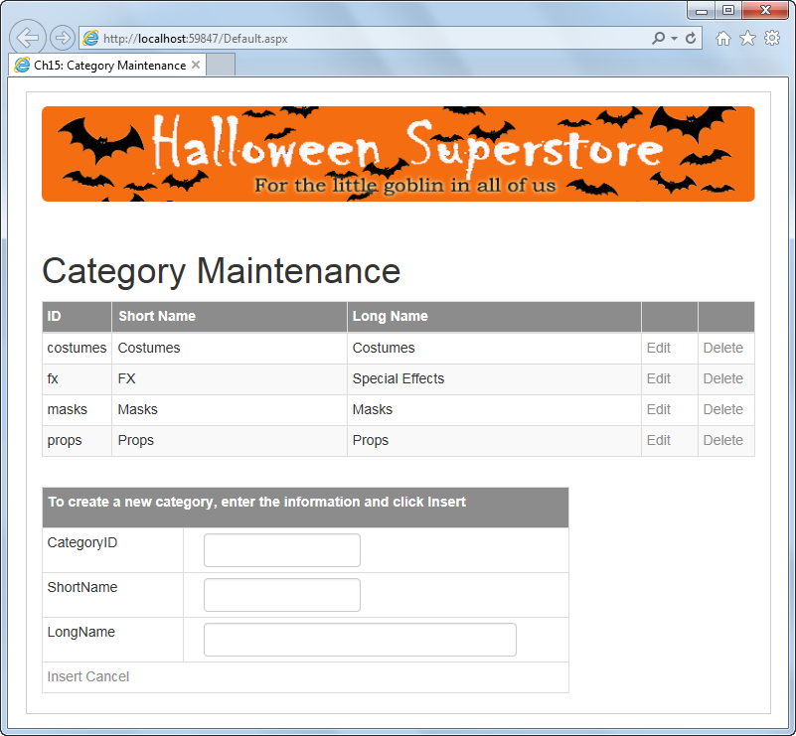

Add the DetailsView control

1. Open the XEx15CategoryMaint application in your exercises_extra directory. This is the Category Maintenance application with templates that you saw in chapter 14.
2. Delete the labels and text boxes that are used to enter a new category. In addition, delete the Add New Category button and the event handler for the Click event of that button.
3. Add a DetailsView control below the paragraph that contains the label for displaying error messages and give it an appropriate ID.
4. In Source View, delete the Height and Width properties that are generated by default for the DetailsView control. Then, assign these classes to the control: table, table-bordered, and table-condensed.
5. Add a HeaderTemplate element to the control. Then, move the <p> tag with the instructions for adding a new Category inside this element. Change the text so it tells the user to click Insert rather than Add New Category. Finally, add a HeaderStyle element and assign the bg-halloween class to it.
6. Bind the DetailsView control to the same data source that’s used by the GridView control. This will generate bound fields for the control.
7. Add a command field that will let the user insert rows, and set the DefaultMode property of the control to Insert.
8. Add an event handler for the ItemInserted event of the DetailsView control. Then, add code that checks if a SQL exception has occurred.
9. Run and test the application to make sure you can insert a new category. Then, leave one or more fields blank and see what happens when you try to do an insert.

Convert the bound fields to templates and implement validation

For the following steps, you can work in either Source View or Design View, though it might be easiest to work in Source View.

1. Convert all three of the bound fields of the DetailsView control to template fields. Then, delete the Item and EditItem templates for each field since the control will be used only for inserting.
2. Assign an appropriate name to the text box within the InsertItem template for each field. Then, assign the form-control class to each text box.
3. Move the required field validators within the appropriate InsertItem templates. Then, modify the validators so an asterisk will be displayed in the validator when an error occurs and the error message will be displayed in the validation summary control you’ll add in the next step. When you’re done, delete the div elements that are assigned the form-group class.
4. Add a second validation summary control below the DetailsView control. This control should be identical to the one below the GridView control, except it should be assigned to the New validation group.
5. Modify the command field for the DetailsView control and the validators for that control so they’re also assigned to the New validation group.
6. Run the application and click the Insert button in the DetailsView control without entering any data to be sure the validators work correctly. If they do, note that the asterisks display below the text boxes.

Make some formatting adjustments with Bootstrap

1. In the InsertItem template, add a div element for each text box and assign a Bootstrap column class to each div element. The first two div elements should span 6 columns, and the last div element should span 11 columns.
2. Move each text box within its corresponding div tag.
3. Run the application and test it to make sure that the asterisks now appear next to the text boxes rather than below them.